**Understanding Business Organisations: British Airways**

**Contents**

Introduction 3

Business Organisational Purpose 3

Organizational Structure 4

Organisational functions 6

Organisational culture 8

SWOT analysis 10

PESTEL analysis 12

Conclusion 15

Reference 16

# Introduction

A business organization is one that meets the needs of its customers by producing things or providing services. With more than 159 destinations globally, British Airways is the largest internationally planned airline in the UK. The airline serves tourist as well as business passengers and represents a major facilitator of investments and trade in the UK industry. For this assignment, the researcher looked at the positions structure of operations, and culture of British Airways. Utilizing the external and internal factors that impact their organization as a result of novel situations. The brand has served as a worldwide airline connecting people, places, and diverse cultures. The company is the largest foreign airline in the United Kingdom and ranks among the most prestigious in the world of travel. It belongs to the Global Aviation Group. The airline goes via over 180 sites in eighty nations, operating out of London Heathrow, which is among the busiest airports in the entire globe. Amongst the more than 280 airplanes in the airline's inventory are the Boeing mode A380 including 787. Currently, the brand employs over 34,999 workers, which includes 5,499 engineers, 3,599 agents for flights, and 14,999 passenger service personnel. Apart from souvenirs and antiques, the brand Heritage collection has an extensive document archive that documents the beginnings, development, and functioning   and previous entities. BA provides planes with scheduled passengers and commercial flights. International flights are routinely scheduled on BA's network. BA provides planes with scheduled passenger and freight flights. Versions of Embraer, Airbus, and Boeing make up British Airways' fleet. British Airways operates both short- and long-haul planes. The company also provides protection, packaged vacation, airline advertising, and aircraft maintenance services.

# Business Organisational Purpose

The company takes part in several CSR projects that target local communities, customers, the environment, and its multiple partners. The company must abide by rules of ethics and law in order to continue carrying out its duty of operation. To fulfill its various responsibilities, the brand has developed a variety of tactics. All company practices include consideration of these tactics in the decision-making process. According to Tariq (2024), the organization has developed an extensive rules of conduct that all employees and executives are required to follow with the goal to ensure that the corporation is abiding by its moral commitments. The brand requires a range of resources, involving financial, human, and aviation equipment supplies, required to function in the airline industry.

Given the present monetary crisis and a recession, the firm needed to reevaluate its financial position to maintain the sustainability and effectiveness of its business activities. Nearly all American and British firms focused on cutting expenses in order to mitigate the consequences of the downturn throughout this period, since an extensive amount of companies lost their financial backing and filed for bankruptcy (Hung et al., 2023). Although BA had several options to decrease expenses, the company decided against violating any of its codes of conduct in favor of making decisions about reducing expenses that were not going to harm its customers or employees.

British Airways is headquartered in Harmondsworth and its principal airline hub is situated at Heathrow Airport in the centre of London. As implied by the name, much of its corporate procedures are based on UK government patterns and policies. The UK emphasizes in the fair and competitive character of the business environment and has rather specific legislation regarding the use of fair trade in the context of business (Disma et al. 2024). The business rules implemented by the UK government guarantee that all companies may remain in the market on the basis of competition. The rules that guarantee that businesses in any industry compete with one another fairly are known as the UK's competitive policies in the business ecosystem.

# Organizational Structure

A member of the “International Airline Group (IAG)” is British Airways. AIG owns British Airways in addition to Iberia, Vueling, and Aer Lingus. The airline group is organized as follows:

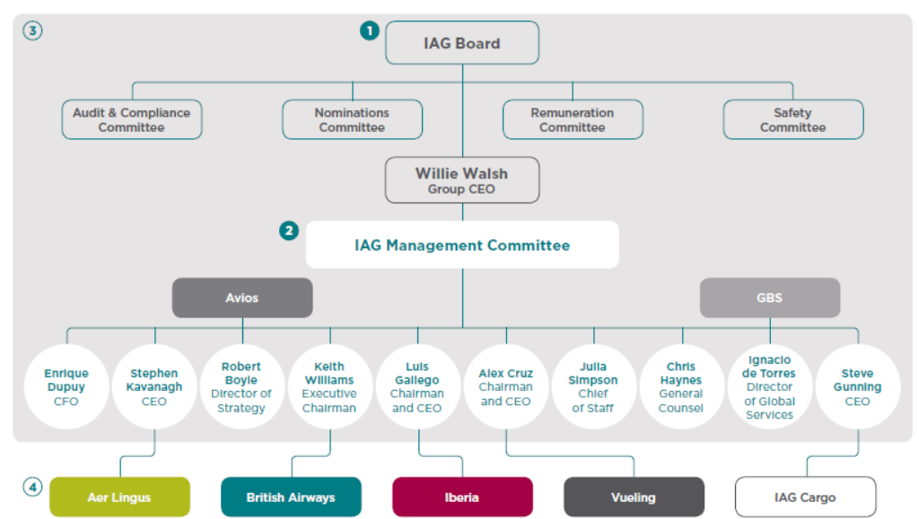

In early 2015, the brand made a number of changes to its corporate structure. According to the company, it will split up its marketing team, with one employee rejoining the commercial segment and the other forming a new customer experience team specifically focused on the travel and tourism sector. Athanassoglou et al. (2023) looked at this pattern of rearrangement, which is clearly an attempt to give preference to branding in the airline's marketing strategy. The figure below depicts BA's current structure of operations before Alex Cruz took over as CEO in 2016 after Keith Williams retired.

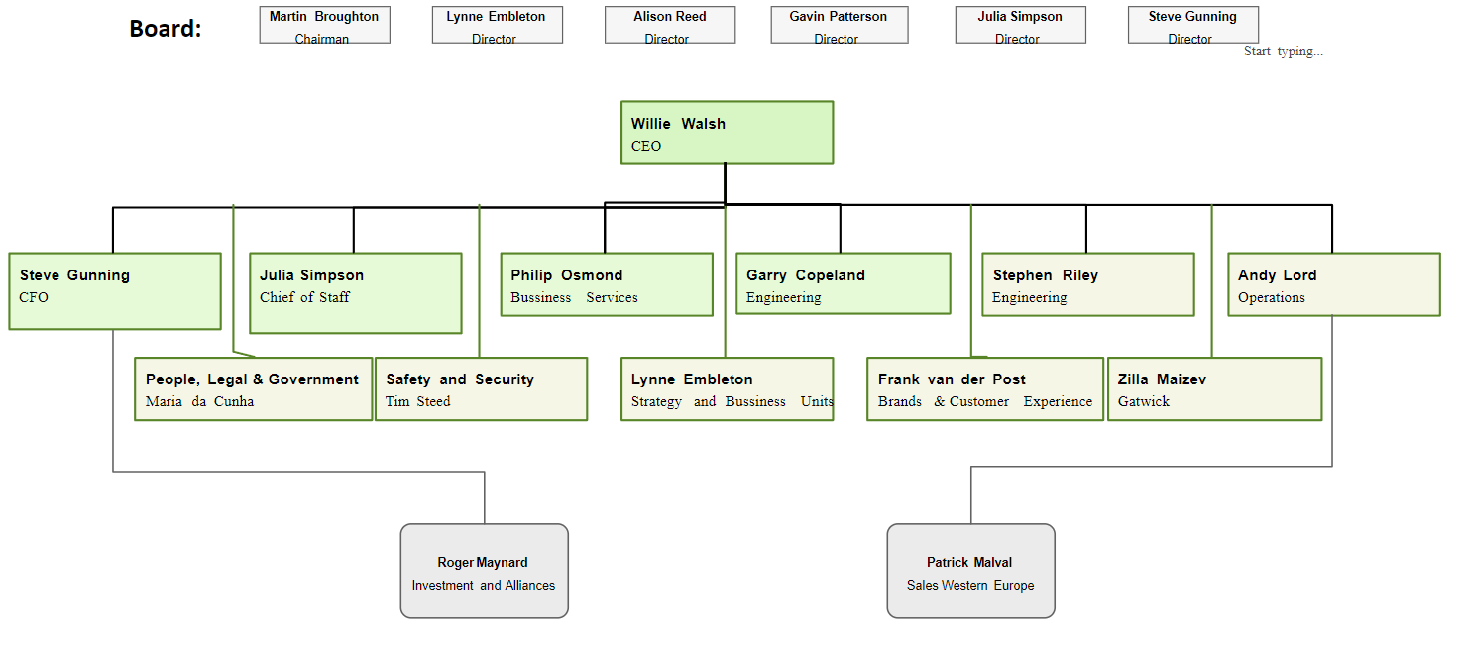

The CEO leads the company's core leadership team, with the leadership team, board, customers, and operational executives arranged in descending order. These people are the only people that the top executives must answer to. They are the company's decision-making machinery. The company's executives are the ones who carry out the choices that the executive makes. These comprise the departments of investment, consumers, and advertising. As examined McWilliam et al. (2023), he executive then transfers responsibility to the next level, which makes sure management is handling the company's operations smoothly. At this level, operators make sure that all of the organization's technical requirements are met.

The low levels make sure that every business activity is executed precisely in order to guarantee effectiveness. The division of management tiers guarantees that there are a few subordinates under supervisors. The tight collaboration between supervisors and subordinates is a particularly beneficial aspect of this strategy. As said by Wang et al. (2023), because the representatives in the customers department reflect the opinions of the clients, the department's participation in the business aids in improved service delivery.

BA’s organizational structure minimises inefficiencies that may have arisen over the course of performing its duties. Every department is guaranteed representation in the upper management thanks to the structure. This guarantees the open and effective flow of information across every division. The execution of decisions has been delayed as a result of the organizational structure. As said by Xie et al. (2023), this is because there are several levels in the hierarchy where decision-making is not shared by the actual implementers. Making choices is not including those on the ground, which might result in resistance during execution. While division of labor restricts flexibility in the workplace, it is not cost-effective for any business.

# Organisational functions

British Airways cultivates a corporate and socially responsible culture. It makes an effort to use its employees to foster innovation and growth. Training sessions are regularly held to enable staff members to continue developing on all fronts. The organization's higher management wants to foster employee engagement and develop future leaders. As said by Strachan (2023), employees have the opportunity to progress within the company and achieve higher postings and positions by working hard and developing intellectually as higher roles are filled from within the workforce.

British Airways provides incentives and bonus packages to its staff in order to foster motivation. The workforce as a whole is diverse and offers equal job chances to men and women, notwithstanding the senior the management's male predominance. It's clear that British Airways values its workers and encourages them to grow inside the company rather than leaving for more lucrative possibilities elsewhere. As stated by Gualini et al. (2023), stakeholders are comprised of four groups: employees, shareholders, suppliers, and stakeholders. The main problem facing the workers is that, as a result of the recession in recent years, less people have been traveling, which has negatively impacted the tourist sector as a whole. As a result, flights are either discontinued entirely or rerouted to other, busier locations. It becomes concerning when there is downsizing and employee layoffs (Farghali et al. 2023). Reductions in tourism translate into fewer earnings or higher costs for the shareholders.

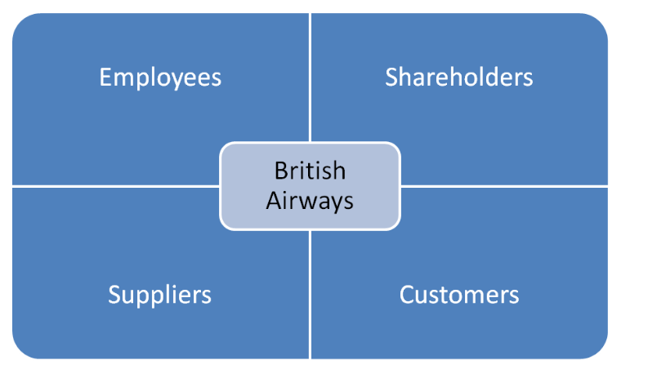

BA saw a sharp rise in call volumes and the opening of a new service center in Newcastle-upon-Tyne due to a high personnel turnover rate. Due to the nature of airport operations, this sizable institution known as the IT Centre operates around-the-clock and serves as the primary point contact for all incoming IT concerns from all over the world. Over 139,999 users are supported by the ITSC staff. As examined Saini et al. (2023), the main problem was bringing separate teams together throughout Heathrow and the recently opened Newcastle facility, improving talent attrition, and staffing this vital business with the proper capabilities, especially the core Service Desk.

In order to minimize the administrative burden associated with overseeing such a vast pool of resources, BA also looked for a partner capable of meeting these demands. The culture is characterized by bureaucracy. This culture's power lies on its foundations. The authority is derived from descriptions of tasks, and communication occurs inside processes, regulations, and systems. As stated, by Herrero-Cortina et al. (2023), there is limited collaboration, and the system offers the necessary integration. It is not encouraged to perform. The culture of roles is appropriate for an organization that does not experience constant change. Its culture has shifted to one that is customer-oriented after privatization.

Alongside hierarchies and functions, there had been bureaucracy. The approach has shifted to one of the empowerments of workers. This indicates that staff members from many departments and outside of the official structure assist management. Three categories of business processes are involved: supporting, operation, and management processes. As said by Lux et al. (2023), governance of companies and strategic planning are two components of a system that work together to form the leadership process. Since strategic planning encompasses company strategy, it is crucial to the management process. Evaluation of risks, handling risks, managing financial outcomes, and management accountability for threat contingency planning, guaranteeing quality, catastrophe recovery, and fulfilling.

# Organisational culture

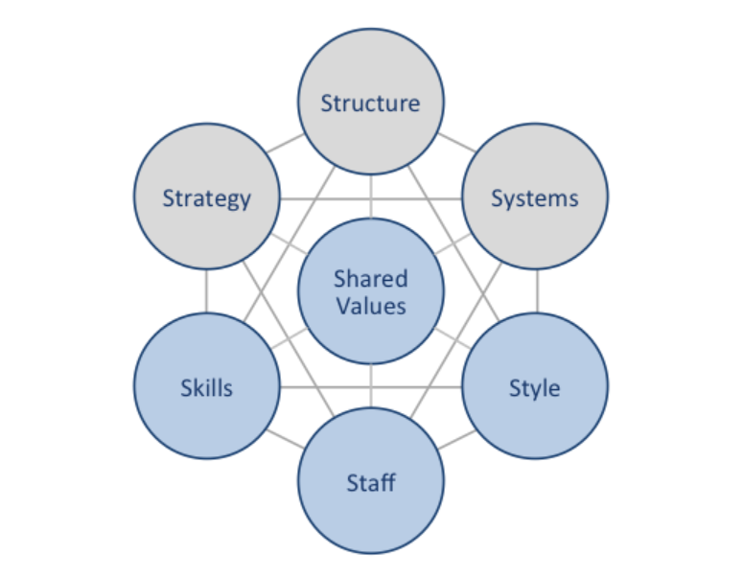

The British Airways McKinsey 7S framework demonstrates how the seven discrete components of the airline industry are synchronized to enhance the business's overall efficacy. Elements are separated into both soft and hard categories by McKinsey 7S. While common values, staff, talents, and style are considered soft aspects, plans, framework, and processes are considered hard elements.

**Strategy:** Differing services is a company strategy that it follows. The airline specifically sets itself apart from the competition by heavily relying on information technology and digitization, as well as by offering highly customized services. As said by Keke (2023), another essential element of a business plan is aggressive foreign market expansion, with the aviation firm scheduled to launch more than a dozen additional routes in 2016 isolated.

**Structure:** It is owned by IAG, one of Europe's biggest airline groups, which also owns Vueling, Aer Lingus, and Iberia. The hierarchical organizational structure of British Airways is indicative of the company's substantial size (Eliason et al. 2023). As part of his extensive cost-cutting efforts, the new CEO of British Airways is anticipated to implement de-layering initiatives into the airline's organizational structure.

**Systems:** It maintains a variety of industry-specific systems in addition to the basic set of organizational systems including those for personnel recruiting and selection, performance reviews, quality control, and addressing complaints. As said by Amankwah-Amoah et al. (2023), these consist of, among other things, the in-flight entertainment system, luggage handling system, and passenger check-in system.

**Style:** Since every airline has a particular set of objectives, airlines will need to adopt leadership styles that will strengthen their company's competitive edge. For instance, Ryanair's authoritarian leadership style has worked well for them since their chief executive officer aims to save costs. However, this approach discourages subordinates' dedication, innovation, and drive. To compete with its competition, BA will have to adopt a new strategy to get beyond these obstacles.

**Staff:** Resources and guidance are also provided to their managers to aid in the growth of their teams. They offered residential training to middle managers as part of a development program designed for women. The growing market worth of airlines is reflected in the expectations they have for their employees; as the overall airline sector improves, so do the staffing needs.

**Skill:** This examines the skills that the employees of the organization have. In order to obtain a competitive edge, British Airways will need to do research on the skills required to support any new strategies or organizational changes. For instance, in the management and administrative community, personnel have access to online learning support tools for productivity and individual development appraisals.

**Shared Values:** It deals with the kind and quantity of workers that a company will require as well as their recruitment, training, motivation, and compensation strategies. According to McKinsey, it is considered a soft aspect since it is difficult to quantify and less concrete when trying to be described. Nonetheless, corporate culture has a greater effect (Ran et al. 2023). The majority of European airline companies now only require a small number of staff due to technological advancements. Successful company expansion drives employee motivation, and they receive one of the greatest industry salaries to affect performance.

# SWOT analysis

|  |  |
| --- | --- |
| **Strength**   * Sustainability is a major priority for British Airways. The firm has implemented a proactive strategy by initiating the Better World Program. * Investing in ZeroAvia, a hydrogen propulsion firm developing aircraft with more than 50 seats that can fly on zero emissions hydrogen-electric authority, is one of the program's goals. * Additionally, the business has begun purchasing environmentally friendly aviation fuel from a variety of vendors, and planes that travel throughout England and Scotland utilize 34.99% of the sustainable gasoline. * Along with emphasizing their mental health, the initiative also promotes inclusiveness and diversity in employment. | **Weakness**   * British Airways has been dealing with engine problems for a number of years because airline has sometimes had to ground its aircraft for an entire year at a time owing to engine failure. * It has suffered losses during the COVID, and staff are not satisfied. * As stated Sajjadian (2023), the corporation intends to restructure by laying off 12,000 workers and offering the remaining workers' conditions and terms for contract renewals through organizations. |
| **Opportunity**   * The airline are having lots of troubles because they are following traditional structure. * Staff members depends on union ship which leads to voice against the company. * Their complaints are unable to address management directly which leads to conflict. | **Threat**   * The brand is a member of the “International Airlines Organization” which was formerly regarded as one of carrier represent EU. * As said by Kek et al. (2023), nevertheless, in the event of Brexit, the brand will not take some benefits from EU regulations. * This have mandate that any airline operating in the union be managed and owned by an EU-based business. * Following the UK's departure from the EU, legislation have altered. According to the existing slot regulations, corporations risk losing their slots if they don't use their slot threshold 69.99% of the time. It is having problems since it does not have enough employees to run the planes at full capacity. * Qantas and several other smaller airlines, like Fly Dubai in the UAE and Indigo in India, are market leaders in their respective countries. With a 52.99% market share, this is the top product in the UK. |

# PESTEL analysis

|  |  |
| --- | --- |
| **Political** | * Governments from both local and foreign  impose strict policies, tax and other regulations on this chosen sector. * The overall cost of operation done by the brand may be affected by certain restrictions. * Foreign agreements will be impacting the business of the brand including capacity to grow its network of flights (Eastwood et al. 2023). * The corporation faced major ramifications from the UK's decision to leave the EU. |
| **Economy** | * The whole aviation sector was badly hit by the COVID-19 pandemic-related worldwide economic crisis. * They generate lots of income from various part of the globe which leads to high financial performance. * For UK citizens, travelling abroad may cost more if the pound is robust. * Utilises various strategy to help airlines for lowering the overall risk or significant fluctuations or problem in oil prices. |
| **Social** | * Modifications on lifestyle and culture in society would impact passenger overall preferences and travel behaviours. * Customers are becoming more health conscious choosing flights are eco-friendly and provides better service * As said by Meadowcroft and Rosenbloom (2023), passengers' expectation for safety precautions had increased a lot. * This had raised after COVID-19 epidemic which will be there for lifelong . |
| **Technology** | * Airlines must invest in user-friendly digital platforms this will help to attract all the present young generation customers. * As said by Zaidi (2023), for the company to satisfy customers and maintain its competitive edge, it must stay up to date with these technical developments. * The brand using big data to secure their data from cybercriminals and providing cybersecurity to protect stakeholders’ data. |
| **Legal** | * Being a worldwide transporter, the brand must abide by the laws and ordinances of every country in which it conducts business. They may encompass anything from entitlements to aviation to security of information. * They have to abide by labor regulations, which vary greatly between nations. * Wages, conditions of employment, and rights for workers are all covered by these statutes. * Changes in those regulations might have an impact on the company's labor costs and policies. Aircraft are subject to a number of laws that protect people's privileges. |
| **Environment** | * Because the aviation sector greatly increases carbon emissions, it has come under fire and is under more regulatory scrutiny. * Lowering its carbon impact while expanding is a problem for the corporation. * One major problem is noise comes from their airplane during the runways. * There are obstacles which include as price, accessibility, and the requirement using advanced technology. |

# Conclusion

The organizational makeup of a business is crucial to its success. The organizational structure of the corporation has greatly aided in its accomplishments. To improve the company's efficiency, the flaws that have been found must be fixed. The business should endeavor to increase its technological investment as it will contribute to better service delivery. The pest analysis details the necessary steps to take in order to reach the intended state. It is evident that focusing on sustainability and utilizing a variety of technologies may benefit  brand  by improving operational efficiency, giving it a competitive advantage, and improving the airline's reputation with different stakeholders.

# Reference

Amankwah-Amoah, J., Debrah, Y.A. and Acquaah, M., 2023. Business failures in institutionally weak environments: An examination of Virgin Atlantic’s failed adventure in sub-saharan Africa. International Business Review, 32(5), p.102146.

Athanassoglou, V., O’Sullivan, E.P., van Zundert, A. and Pandit, J.J., 2023. New guidelines for research in airway device evaluation: time for an updated approach (ADEPT-2) to the Difficult Airway Society’s ‘ADEPT’strategy?. Journal of Clinical Monitoring and Computing, 37(2), pp.345-350.

Disma, N., Asai, T., Cools, E., Cronin, A., Engelhardt, T., Fiadjoe, J., Fuchs, A., Garcia-Marcinkiewicz, A., Habre, W., Heath, C. and Johansen, M., 2024. Airway management in neonates and infants: European Society of Anaesthesiology and Intensive Care and British: Journal of Anaesthesia: joint guidelines. European Journal of Anaesthesiology| EJA, 41(1), pp.3-23.

Eastwood, M.C., Busby, J., Jackson, D.J., Pavord, I.D., Hanratty, C.E., Djukanovic, R., Woodcock, A., Walker, S., Hardman, T.C., Arron, J.R. and Choy, D.F., 2023. A randomized trial of a composite T2-biomarker strategy adjusting corticosteroid treatment in severe asthma: a post hoc analysis by sex. The Journal of Allergy and Clinical Immunology: In Practice, 11(4), pp.1233-1242.

Eliason, P.H., Galarneau, J.M., Kolstad, A.T., Pankow, M.P., West, S.W., Bailey, S., Miutz, L., Black, A.M., Broglio, S.P., Davis, G.A. and Hagel, B.E., 2023. Prevention strategies and modifiable risk factors for sport-related concussions and head impacts: a systematic review and meta-analysis. British journal of sports medicine, 57(12), pp.749-761.

Farghali, M., Osman, A.I., Mohamed, I.M., Chen, Z., Chen, L., Ihara, I., Yap, P.S. and Rooney, D.W., 2023. Strategies to save energy in the context of the energy crisis: a review. Environmental Chemistry Letters, 21(4), pp.2003-2039.

Gualini, A., Zou, L. and Dresner, M., 2023. Airline strategies during the pandemic: What worked?. Transportation Research Part A: Policy and Practice, 170, p.103625.

Herrero-Cortina, B., Lee, A.L., Oliveira, A., O'Neill, B., Jácome, C., Dal Corso, S., Poncin, W., Muñoz, G., Inal-Ince, D., Alcaraz-Serrano, V. and Reychler, G., 2023. European Respiratory Society statement on airway clearance techniques in adults with bronchiectasis. European Respiratory Journal, 62(1).

Hung, A., Koch, S., Bougault, V., Gee, C.M., Bertuzzi, R., Elmore, M., McCluskey, P., Hidalgo, L., Garcia-Aymerich, J. and Koehle, M.S., 2023. Personal strategies to mitigate the effects of air pollution exposure during sport and exercise: a narrative review and position statement by the Canadian Academy of Sport and Exercise Medicine and the Canadian Society for Exercise Physiology. British Journal of Sports Medicine, 57(4), pp.193-202.

Kek, H.Y., Saupi, S.B.M., Tan, H., Othman, M.H.D., Nyakuma, B.B., Goh, P.S., Altowayti, W.A.H., Qaid, A., Wahab, N.H.A., Lee, C.H. and Lubis, A., 2023. Ventilation Strategies for Mitigating Airborne Infection in Healthcare Facilities: A Review and Bibliometric Analysis (1993 to 2022). Energy and Buildings, p.113323.

Keke, M.E., 2023. Impact of digital marketing on the aviation industry. In E3S Web of Conferences (Vol. 402, p. 02009). EDP Sciences.

Lux, B., Schneck, N., Pfluger, B., Männer, W. and Sensfuß, F., 2023. Potentials of direct air capture and storage in a greenhouse gas-neutral European energy system. Energy Strategy Reviews, 45, p.101012.

McWilliam, S., Nielsen, B.B. and Kottaridi, C., 2023. Global value chains and liability of international connectivity: MNE strategy post COVID-19. European Journal of International Management, 21(1), pp.121-139.

Meadowcroft, J. and Rosenbloom, D., 2023. Governing the net-zero transition: Strategy, policy, and politics. Proceedings of the National Academy of Sciences, 120(47), p.e2207727120.

Ran, B., Qiu, S., Zhang, Y., Zeng, L., Zhu, J., Xiang, Z. and Long, J., 2023. Air conditioning energy consumption measurement and saving strategy analysis for an office building in hot summer and cold winter area. Advances in Building Energy Research, 17(1), pp.73-97.

Saini, A., Truong, D. and Pan, J.Y., 2023. Airline efficiency and environmental impacts–data envelopment analysis. International Journal of Transportation Science and Technology, 12(2), pp.335-353.

Sajjadian, S.M., 2023. A critique on the UK’s net zero strategy. Sustainable Energy Technologies and Assessments, 56, p.103003.

Strachan, H., 2023. Strategy and democracy. In Survival: Global Politics and Strategy (April-May 2020) (pp. 51-82). Routledge.

Tariq, M.U., 2024. Enhancing Cybersecurity Protocols in Modern Healthcare Systems: Strategies and Best Practices. In Transformative Approaches to Patient Literacy and Healthcare Innovation (pp. 223-241). IGI Global.

Wang, Z., Calautit, J., Tien, P.W., Wei, S., Zhang, W., Wu, Y. and Xia, L., 2023. An occupant-centric control strategy for indoor thermal comfort, air quality and energy management. Energy and Buildings, 285, p.112899.

Xie, S.H., Kurz, W.A. and McFarlane, P.N., 2023. Substitution benefits of British Columbia’s mitigation strategies in the bioeconomy. Mitigation and Adaptation Strategies for Global Change, 28(3), p.18.

Zaidi, W.H., 2023. The British Aircraft Industry and American-Led Globalisation, 1943–1982 by Takeshi Sakade. Technology and Culture, 64(3), pp.955-956.